Vehicle Detection and Monitoring
using Magnetic Field Sensors

Nikunj Tonthanahal Pradeep Kumar .N Nafeeya Samar Noor Zahara
Dept. of ECE, BNMIT Dept. of ECE, BNMIT Dept. of ECE, BNMIT Dept. of ECE, BNMIT
Bangalore, India Bangalore, India Bangalore, India Bangalore, India
nikunj888@gmail.com pradeepkumar.email@gmail.com nafeeya@yahoo.com noor91zahara@gmail.com

Abstract— In times of rapidly expanding mega cities all around the world, traffic congestion and mobility are becoming a growing problem. Only too familiar are the pictures of crowded highways packed with cabs, bikes, and cars, where nothing is moving due to constant traffic jams. Hence making traffic flows more efficient will be of greater importance with each passing day. By controlling the traffic, both travel time and negative impact on the environment can be reduced. However, efficient control requires cost-efficient and accurate estimation of traffic parameters, such as the number of vehicles passing a certain point per unit time, the current speed of vehicles, and their types. The most popular methods of acquiring traffic parameters that are currently used in India, i.e. video image processing and infrared sensors, suffer from several drawbacks such as dependence on clear environmental conditions and suitable ambient light requirements. The objective of the project is to develop a traffic monitoring and classification system using low power, low cost magnetic sensors and induction loops that are free from the aforementioned drawbacks. The magnetic materials in a vehicle change the ambient magnetic field when the vehicle passes over the magnetic field sensors. This change is used to detect the vehicles moving over the sensor. The amount of change in magnetic field depends on the volume of the magnetic materials in the vehicle. Since two wheelers have comparatively lesser volume of magnetic materials, they produce smaller changes in the magnetic field compared to four wheelers. This difference is used for classification of the vehicles. The data acquired from this system is used to increase the efficiency of the existing roadways and to enhance the capacity of transportation networks at locations where the traffic densities are large.
Index Terms— Traffic Monitoring, iSense core, Gateway and Vehicle detection modules, Induction loops, Wireless sensor networks, ZigBee communication, Colpitt’s oscillator, Arduino 2560.

Introduction
In times of rapidly expanding mega cities all around the world, traffic congestion and mobility are becoming a growing problem. Maximizing the efficiency and capacity of existing transportation networks is vital because of the continued increase in traffic volume and the limited construction of new highway facilities in urban, inter-city, and rural areas. Even when additional facilities are built to ease congestion and promote the use of multiple occupancy vehicles, the cost is often quite high. An alternative to expensive new highway construction is the implementation of strategies that promote more efficient utilization of current road, rail, air, and water transportation facilities. Efficient control requires cost-efficient and accurate estimation of traffic parameters, such as the number of vehicles passing a certain point per unit time, the current speed of vehicles, and their types. The estimation can be based on data collected from magnetic sensors placed close to the road or induction loops buried into the road surface.
A vehicle is built up of several types of magnetic materials; soft magnetic materials with no residual magnetization and hard magnetic materials with high residual magnetization. All of these materials in the vehicle create a disturbance in the earth magnetic field when the vehicle passes a specific region. When a magnetic sensor system with high field sensitivity and resolution, or a simple induction loop in placed in this region, it is possible to detect this change and hence the presence of vehicle. A generic block diagram of such a simple vehicle detection and monitoring system is shown in Fig. 1.

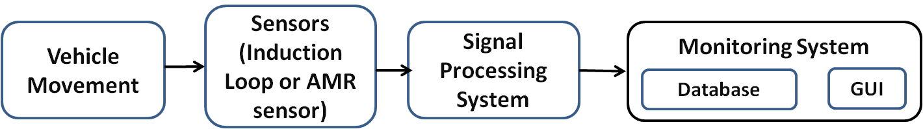
Fig 1: Block diagram of simple vehicle detection and monitoring system

The signal processing system processes the data from the sensors to eliminate any errors or false detections. Finally the traffic parameters acquired from the sensors are updated in a database and displayed using a GUI on the computer.
This project implements the induction loop as a means of acquiring vehicle count and classifying vehicles into two wheelers and four wheelers. The AMR sensors are used to acquire the count and speed of the vehicles.

Hardware Description

Induction Loop Detection System
The principal components of an inductive-loop detector system as shown in Fig.2 include:
- One or more turns of insulated loop wire wound in a shallow slot sawed in the pavement.
- Lead-in cable from the curbside pull box to the intersection controller cabinet.
- Electronics unit housed in a nearby controller cabinet.
Inductive-loop wire, lead-in wires, and lead-in cables typically use #12, #14, or #16 American Wire Gauge (AWG) wire. Here, a #12 AWG wire is used. The loop in the roadway also contains an induced resistance (called the ground resistance) caused by transformer coupling between the loop and induced currents flowing in the roadway and sub grade materials. A roadway inductive loop has a non-uniform flux field that produces an inductance value given by

(1)

where,
_{r} = Relative permeability of material (1 for air)
₀ = 4 x 10⁻⁷ henrys per meter.
L = Inductance, henrys
N = Number of turns
I = Coil current, amperes.
A = Cross sectional area of coil, m²
F' = a factor to account for the non-uniform flux in the roadway inductive loop

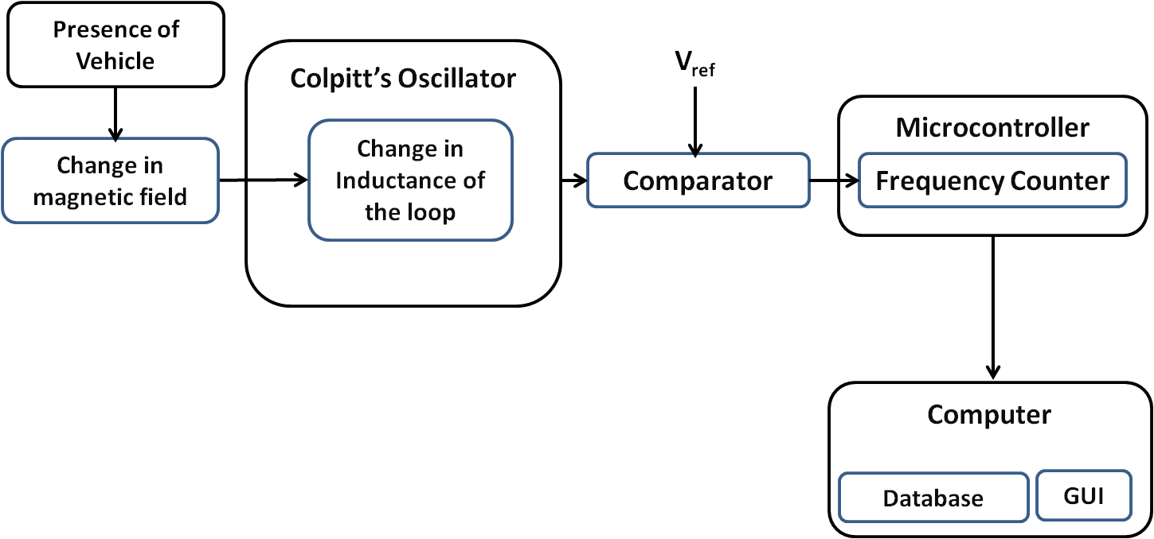

Fig 2: Block diagram of induction loop vehicle detection system

The electronics unit consists of a Colpitt’s oscillator, a comparator and a microcontroller. The inductive loop is a part of the tank circuit of the Colpitt’s oscillator. The oscillator and comparator are built with operational amplifiers. The microcontroller used here is ArduinoATmega2560- an ARM controller. The circuit diagram of the oscillator along with the comparator is shown in Fig 3.
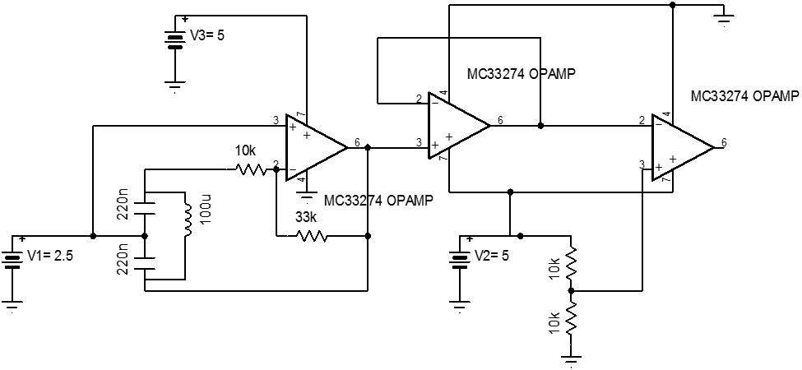
Fig 3: Circuit diagram of Colpitt’s oscillator and comparator

  - AMR Vehicle Detection System

An AMR sensor is a sensing device that utilizes the rate of change of magnetic resistance which is affected by the strength of the external magnetic field to detect the presence of vehicles.
Magnetic sensors were introduced as an alternative to the inductive-loop detector for specific applications. A magnetic sensor is designed to detect the presence or passage of a vehicle by measuring the perturbation in the Earth’s quiescent magnetic field caused by a ferrous metal object (e.g., a vehicle) when it enters the detection zone of the sensor.
Early magnetic sensors were utilized to determine if a vehicle had arrived at a “point” or small-area location. Modern AMR sensors are used for vehicle presence detection and counting. Unlike the inductive-loop detector, the magnetometer are usually used in places where cutting the deck pavement for loop installation is not permitted. Also, the magnetometer probe and its lead-in wire tend to survive in crumbly pavements longer than ordinary loops.

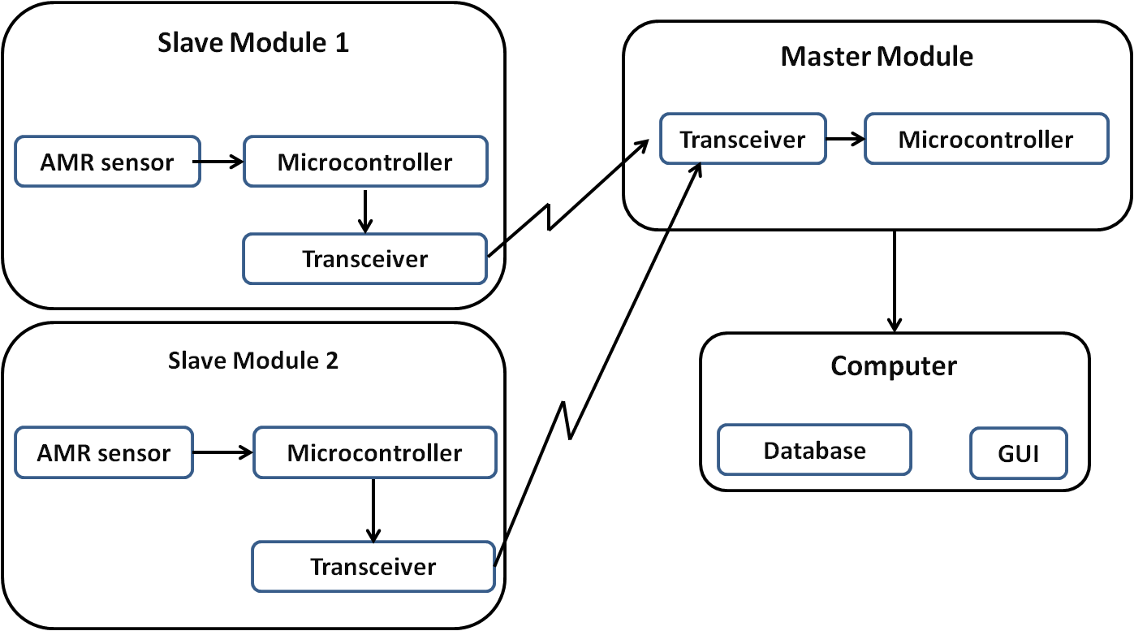
Fig 4: Block Diagram of AMR sensor Vehicle Detection System

The block diagram of the AMR vehicle detection system is show in Fig 4. The system contains two slave modules that are buried along the length of the road with a distance of two meters between them. The slave modules consist of a two axis AMR sensor and a microcontroller interfaced with a ZigBee transceiver. The modules are used for speed calculation and communicate with a master module using ZigBee protocol. The master module consists of a microcontroller interfaced with a ZigBee transceiver and is connected to the computer through UART.

SOFTWARE DESCRIPTION

Induction Loop Detection System
The Arduino integrated development environment (IDE) is used to write a program to measure the frequency drift due to vehicle movement. Signals from the comparator are square waves designed to have amplitude of 5V peak to peak, large enough to be detected by the microcontroller. These waves are fed to one of the input pins of the controller and are monitored.
The movement of vehicle over the loop produces a sinusoidal change in the magnetic field and hence a similar change is observed in the frequency of the oscillator. The concept of negative slope detection is used to detect the departure of vehicle which in effect determines the presence of vehicle and minimizes errors caused due to false counts.
The Arduino IDE supports all the features required for the implementation of this method and hence is used in this project.

  - AMR Vehicle Detection System
The Eclipse C++ IDE integrated with Jennic microcontroller compilers and the Cygwin platform is used for programming the master and slave modules. The iSense API developed by Coalesenses for the modules is used to make the programming more convenient.
The iShell application is used for flashing the program onto the microcontrollers and for monitoring its serial output for debugging purposes.
The GUI is developed on Visual Studio using the C# dot-net framework.

THEORY OF OPERATION

Induction Loop Detection System
An induction loop detector provides a low cost method for detection of vehicles. The system consists of a loop of wire (typically 4 or 5 turns) buried approximately 20 mm below the road surface. The ends of the loop are returned to the vehicle detector usually housed some distance away in the controller cabinet.
The functioning of Inductive loop sensors is as follows. The inductive-loop is a part of the tank circuit of a Colpitt’s oscillator in which the loop wire and lead-in cable are the inductive elements. The comparator acts as an A/D convertor and converts the analog output signal of the oscillator into a square wave. This is fed to a microcontroller which continuously measures the frequency of the square wave input. When a vehicle passes over the loop or is stopped within the loop, the vehicle induces eddy currents in the wire loops, which decrease their inductance. The decreased inductance results in an increase in the frequency of the oscillator output. This increase in frequency is used by the microcontroller to detect the presence of vehicles.
The amount of eddy currents induced in the loop and thus the change in frequency depends on the mass of the ferromagnetic material in the proximity of the loop. Since two wheelers and four wheelers have different amounts of ferromagnetic material in them, the corresponding frequency change as they pass over the loop is also different. This difference is used by the microcontroller to classify the vehicles.
The traffic parameters i.e. the count and classification of vehicles is then sent by the microcontroller to a computer where they are displayed in the GUI and stored in a database. A flow chart for the functioning of the Induction loop detector system is shown in Fig 5.
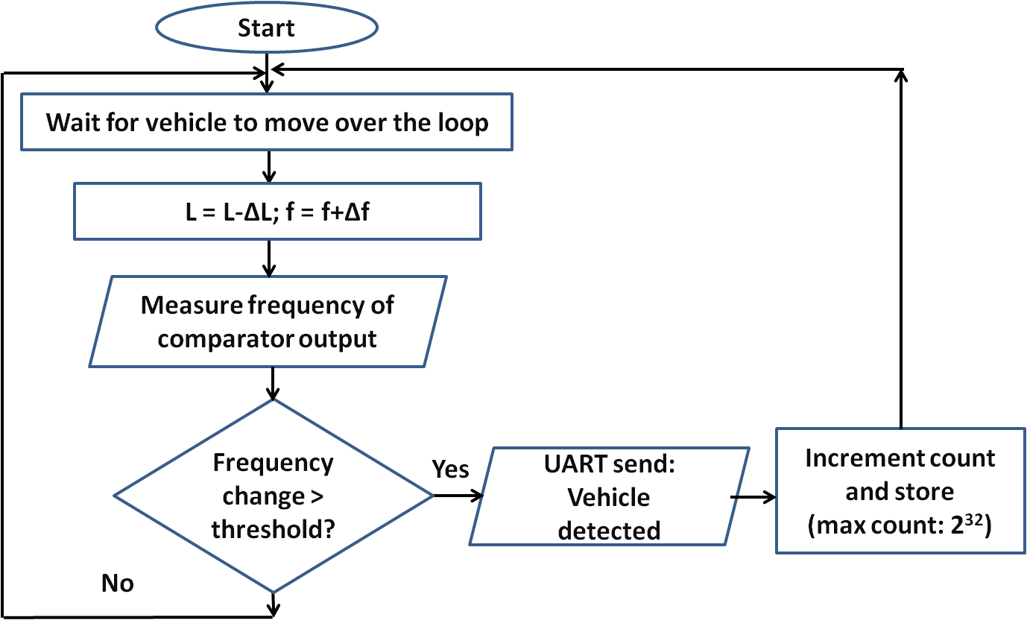
Fig 5: Flow chart for induction loop system

  - AMR Vehicle Detection System
An iron or steel vehicle distorts the magnetic flux lines because ferrous materials are more permeable to magnetic flux than air. That is, the flux lines prefer to pass through the ferrous vehicle. As the vehicle moves along, it is always accompanied by a concentration of flux lines known as its “magnetic shadow” as illustrated in Fig 6. There is reduced flux to the sides of the vehicle and increased flux above and below it. An AMR sensor installed within the pavement detects the increased flux below the vehicle.
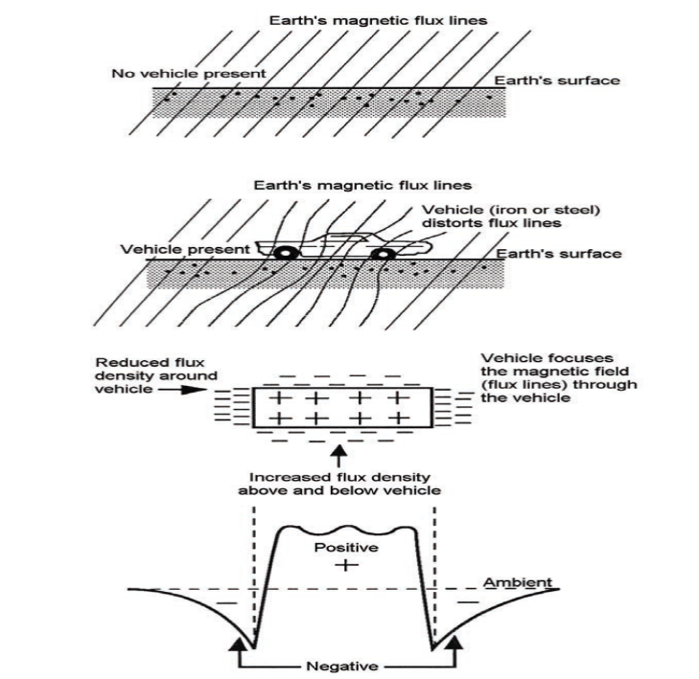 Fig 6: Distortion of Earth’s quiescent magnetic field by a ferrous metal vehicle

The sensors on the slave modules detect the change in the ambient magnetic field. Initially they are calibrated to account for the magnetic field of the ambient environment and the default magnetic field generated by the earth. When a ferromagnetic material (commonly found in vehicles) passes over the sensor it disturbs the magnetic field around it. This change in magnetic field is detected by the sensor. It is observed that the output of the sensor peaks when a vehicle passes over it. These peaks are used to detect the presence of vehicles. An EWMA (Exponentially weighted moving average) filter is used to eliminate the noise in the sensor output and obtain a smooth waveform. The typical output waveform of an AMR sensor when a vehicle passes over it is as shown in Fig 7.
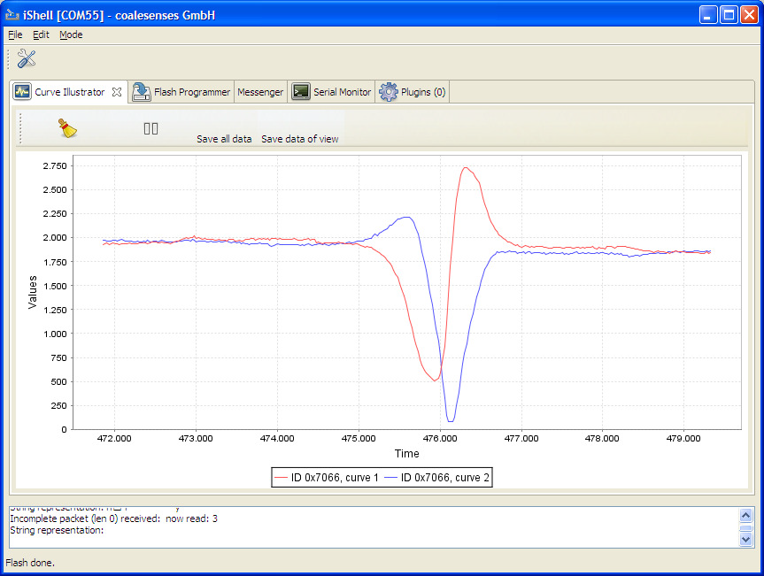
Fig 7: Typical output waveform of the AMR sensor. The red and the blue curves represent the output of the sensor in the two axes.

An algorithm running on the slave module that monitors the slope of the waveform when the sensor outputs cross a threshold is used to detect that a vehicle has passed over it. The absence of the slope detection algorithm can cause multiple detections for the same vehicle since the waveform stays over the threshold for several sampling instants. When a vehicle is detected, a time stamp indicating the time at which the vehicle crossed over the sensor is sent to the master module. The slave modules are buried along the length of the road with a distance of two meters between them. Thus the time stamps sent by the two slave modules differ by a small value Δt as the vehicle passes over the two sensors one after the other. This difference is used to find the speed of the vehicle using the formula

S = D/Δt

Where
S is the speed,
D is the distance between the two sensors
Δt is the time difference
The sensor modules contain an internal clock which is used to keep track of time for which the slave modules are on. The internal clock is started at the moment the sensor modules are turned on. Since both the sensor modules cannot be turned on simultaneously, an initial time difference exists between the clocks of the two sensor modules. This time difference adds to Δt leading to an error in the speed calculation. To eliminate this, the initial time difference is subtracted from Δt. This is achieved using a synchronization algorithm running on the master and slave modules.
When a vehicle is detected, the time difference Δt is calculated by the master module and sent to the PC via UART where the speed is computed and the count and speed are stored in the database.
traffic parameters i.e. the count and speed of the vehicles is then sent by the microcontroller to a computer where they are displayed in the GUI and stored in a database.

results

Induction Loop Detection System
The typical output waveforms of the oscillator and the comparator are shown in Fig 8.
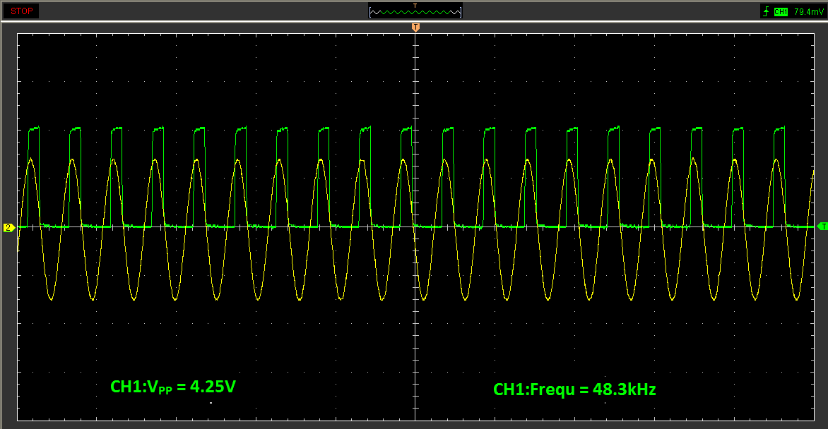

Fig 8: Collpitt’s oscillator and comparator output

When the system is turned on, a high frequency counter sourced by a crystal oscillator is started on the microcontroller. Whenever a rising edge occurs on the input capture pin, the counter value is recorded. The difference in consecutive captured counter values can be used to determine the time period and frequency of the input signal.
A decrease in the inductance of the loop occurs when a vehicle is positioned over it. This decrease causes a corresponding increase in the output frequency of the LC oscillator. This increase is sensed by the microcontroller that outputs a signal to the computer to indicate the presence of a vehicle. The amount of change in the inductance and hence the frequency is used to classify the vehicles as two wheelers and four wheelers.
The dimension of 6ft x 6ft was chosen since the average width of a passenger car and the average length of a two wheeler is 6ft. This is important since maximum frequency drift is observed when the dimension of the metallic object is comparable to the dimension of the induction loop.
A snapshot of the induction loop detector system is shown in Fig 5.

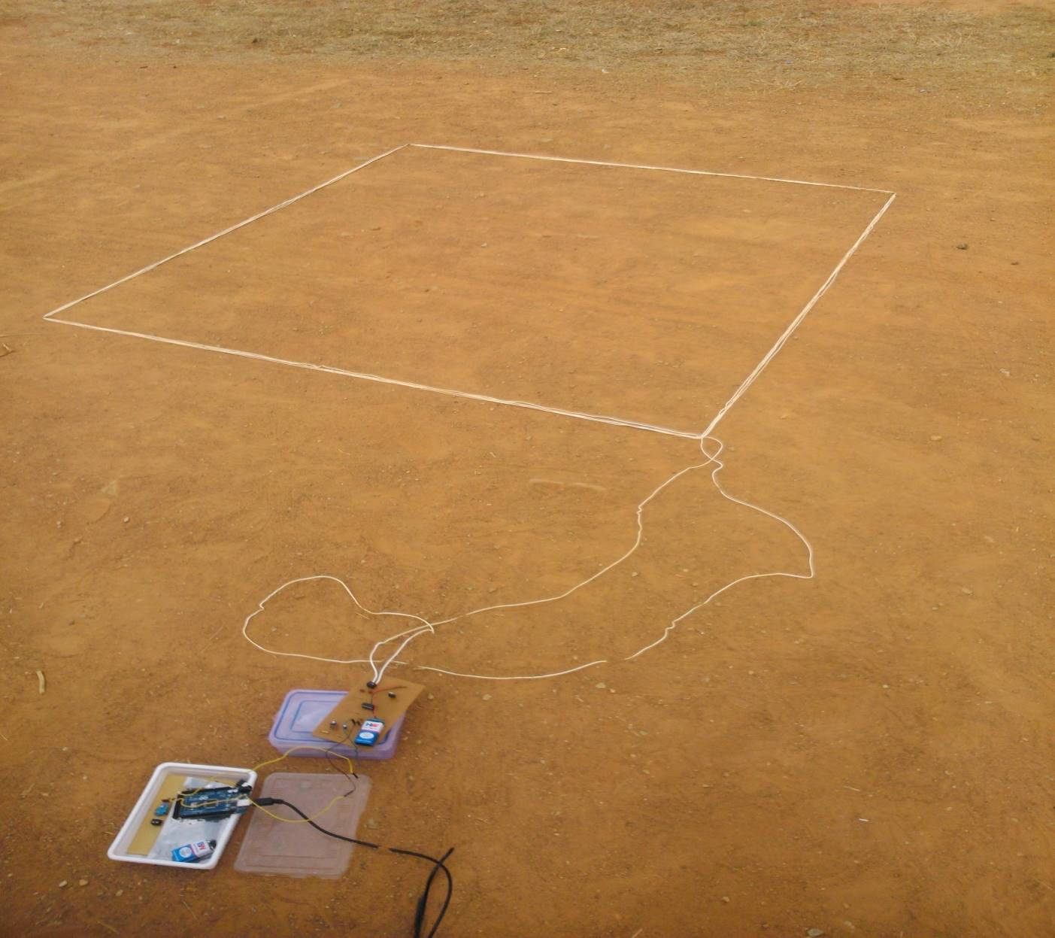

Fig 9: Snapshot of induction loop system

Table I shows the format of the database that stores the data about the count and class of vehicles acquired by the Induction Loop system.

TABLE I. Database format for induction loop detector system
Date | Two wheeler Count | Four Wheeler count | Total count
30/04/2014 | 9 | 9 | 18
01/05/2014 | 5 | 6 | 11
02/05/2014 | 3 | 2 | 5
The induction loop system was tested to determine the frequency drifts for two wheelers and four wheelers at different speeds. Ten trials were carried out at each speed ranging from 10 to 40 for each type of vehicle. The results obtained are tabulated below (Table II and Table III).

TABLE II. Frequency drift values for different speeds in case of two wheelers

Speed (kmph) | Frequency drift (Hz) | Avg. frequency drift
10 | 55 | 55.3
10 | 38 | 55.3
10 | 52 | 55.3
10 | 56 | 55.3
10 | 52 | 55.3
10 | 64 | 55.3
10 | 50 | 55.3
10 | 64 | 55.3
10 | 72 | 55.3
10 | 50 | 55.3
20 | 50 | 48.2
20 | 60 | 48.2
20 | 54 | 48.2
20 | 52 | 48.2
20 | 42 | 48.2
20 | 30 | 48.2
20 | 54 | 48.2
20 | 36 | 48.2
20 | 36 | 48.2
20 | 68 | 48.2
30 | 48 | 39.4
30 | 32 | 39.4
30 | 46 | 39.4
30 | 50 | 39.4
30 | 24 | 39.4
30 | 42 | 39.4
30 | 50 | 39.4
30 | 54 | 39.4
30 | 22 | 39.4
30 | 26 | 39.4
40 | 24 | 34
40 | 44 | 34
40 | 16 | 34
40 | 36 | 34
40 | 50 | 34
40 | 36 | 34
40 | 28 | 34
40 | 26 | 34
40 | 45 | 34
40 | 35 | 34

TABLE III. Frequency drift values for different speeds in case of four wheelers
Speed (kmph) | Frequency drift (Hz) | Avg. frequency drift
10 | 1100 | 1010.8
10 | 896 | 1010.8
10 | 880 | 1010.8
10 | 962 | 1010.8
10 | 872 | 1010.8
10 | 1106 | 1010.8
10 | 1136 | 1010.8
10 | 990 | 1010.8
10 | 1068 | 1010.8
10 | 1098 | 1010.8
20 | 958 | 1006.2
20 | 1262 | 1006.2
20 | 764 | 1006.2
20 | 806 | 1006.2
20 | 1406 | 1006.2
20 | 900 | 1006.2
20 | 856 | 1006.2
20 | 1010 | 1006.2
20 | 960 | 1006.2
20 | 1140 | 1006.2
30 | 1200 | 1000.2
30 | 924 | 1000.2
30 | 986 | 1000.2
30 | 1212 | 1000.2
30 | 688 | 1000.2
30 | 952 | 1000.2
30 | 982 | 1000.2
30 | 872 | 1000.2
30 | 940 | 1000.2
30 | 1246 | 1000.2
40 | 916 | 937.8
40 | 746 | 937.8
40 | 1056 | 937.8
40 | 1014 | 937.8
40 | 936 | 937.8
40 | 960 | 937.8
40 | 1020 | 937.8
40 | 899 | 937.8
40 | 943 | 937.8
40 | 888 | 937.8

Thus the frequency drift is found to decrease with speed in case of both two wheelers and four wheelers. This is due to the fact that the vehicle stays within the loop for a shorter duration of time as the speed increases. Thus the eddy currents induced in the loop is lower resulting in a smaller decrease in inductance. Hence the corresponding increase in frequency smaller results in smaller frequency drifts.

- Accuracy of count
No. of trials = 50
No. of times a vehicle went undetected or detected more than once = 4
Accuracy = 92%

- Accuracy of classification
No. of trials = 50
No. of times a two wheeler was detected as a four wheeler or vice versa = 5
Accuracy = 90%

  - AMR Vehicle Detection System
The AMR sensor vehicle detection system was tested to determine the accuracy of the detected speed for two wheelers and four wheelers at different speeds. Eight trials were carried out for each type of vehicle. The results obtained are tabulated below (Table IV).

TABLE IV Accuracy of the detected speed for two wheelers and four wheelers at different speeds
Type of  vehicle | Actual speed  (kmph) | Detected  speed (kmph) | Error  (in %)
Two wheelers | 10 | 8.98 | 10.2
Two wheelers | 10 | 7.64 | 23.6
Two wheelers | 20 | 18.00 | 10.0
Two wheelers | 20 | 21.56 | 7.8
Two wheelers | 30 | 26.54 | 11.5
Two wheelers | 30 | 28.87 | 3.8
Two wheelers | 40 | 35.64 | 10.9
Two wheelers | 40 | 36.11 | 9.7
Four wheelers | 10 | 10.58 | 5.8
Four wheelers | 10 | 12.00 | 20
Four wheelers | 20 | 18.23 | 8.8
Four wheelers | 20 | 20.57 | 2.8
Four wheelers | 30 | 27.91 | 7.0
Four wheelers | 30 | 30.35 | 1.2
Four wheelers | 40 | 37.22 | 6.9
Four wheelers | 40 | 36.78 | 8.1

The actual error values may differ from the mentioned values since the actual speed was observed on analog speedometers.

- Accuracy of count
No. of trials = 25
No. of times a vehicle went undetected or detected more than once = 1
Accuracy = 96%

CONCLUSION
One of the advantages of Induction loop detector system over AMR sensor vehicle detection system is that the initial installation costs are much lower. They can also detect stopped vehicles. However, significant and reliable change in magnetic field occurs only when the vehicle is completely inside the loop, as against the AMR sensors which are more sensitive to the presence of magnetic materials.
Magnetic sensors are more economical compared to inductive loops as they are easy to reinstall and maintenance costs are low. Magnetic sensors are smaller in size compared to inductive loops which require a minimum area of around 36 sq. ft.
Magnetic sensors have proven to be more immune to noise and stable compared to frequency drifts occurring in the induction loop system due to environmental changes.
Devices embedded in asphalt often get damaged as a result of pressure exerted on the ground by heavy vehicles passing. Small sensors have therefore an advantage over those like large inductive loops, as their re-installation is associated with lower costs.
The sensing and measurement architecture of magnetic sensors uses a minimal level of energy and uses state-of-the-art low-power sensing, amplification, and communication technologies.
Thus magnetic sensor systems are more efficient and reliable than induction loops.

FUTURE ENHANCEMENTS
  - Induction Loop Detection System
- Two loops can be used to determine the speed of the vehicles.
- Methods for solving the problem of detection of vehicles moving parallel to each other can be implemented.

  - AMR Vehicle Detection System

- Sensors with higher sampling rate can be used to classify vehicles based on their magnetic signature.

Auxiliary sensors such as video processing systems and infrared sensors can be used in conjunction with the induction loop and AMR sensor systems to eliminate false counts and increase the accuracy of the traffic parameters acquired.

References
[1] Ravneet Bajwa, Ram Rajagopal, Pravin Varaiya and Robert Kavaler. “In-Pavement Wireless Sensor Network for Vehicle Classification”.
[2] Sing Yiu Cheung, Sinem Coleri Ergen and Pravin Varaiya. “Traffic Surveillance with Wireless Magnetic Sensors”.
[3] Farshad Ahdi, Mehdi Kalantari Khandani, Masoud Hamedi, Ali Haghani. “Traffic data collection and anonymous vehicle detection using wireless sensor networks”.
[4] Traffic Detector Handbook: Third Edition—Volume I. Publication No. FHWA-HRT-06-108.
[5] D. Cebon. Handbook of Vehicle-Road Interaction.
Swets and Zeitlinger Publishers, 1999.
[6] Sun C. (2004). An investigation in the use of inductive loop signatures for vehicle classification. California PATH Research Report UCB-ITS-PRR-2002-4.
[7] Zhang, X., Y. Wang, N.L. Nihan (2004). Monitoring a freeway network in real-time using single-loop detectors: System design and implementation, 83rd TRB Annual Meeting, Washington, D.C.
[8] Ding, J (2003). Vehicle detection by sensor network nodes. MS thesis, Department of Electrical Engineering and Computer Science, University of California, Berkeley, CA.
[9] Oh, S., S.G. Ritchie, C (2002). Oh. Real time traffic measurement from single loop inductive signatures, 81st TRB Annual Meeting, Washington, D.C.
[11] G.S.M. Galandanci & K.O. Ewansiha. Design and simulation of a 20 khz to 50 khz variable frequency oscillator (vfo). www.arpapress.com/ Volumes/ Vol16Issue1/ IJRRAS_16_1_04.pdf
[12] Gordon, R.L., R.A. Reiss, H. Haenel, E.R. Case, R.L. French, A. Mohaddes, and R.
Wolcott; Traffic Control Systems Handbook, FHWA-SA-95-032, Federal Highway
Administration, U.S. Department of Transportation, Washington, D.C., Feb. 1996
[13] Seri Oh, Stephen G. Ritchie, and Cheol Oh. Real Time Traffic Measurement From
Single Loop Inductive Signatures, presented for 81st Annual Meeting of the Transportation
Research board, Washington D.C., January 2002.
[14] Chao Chen, Jaimyoung Kwon, John Rice, Alexander Skabardonis and Pravin
Varaiya. Detecting Errors and Imputing Missing Data for Single Loop Surveillance
Systems, Presented in the 82nd Transportation Research Board Annual Meeting,
Washington D.C., January 2003.
[15] Luz Elena Y. Mimbela and Lawrence A. Klein. A Summary of Vehicle Detection
and Surveillance Technologies used in Intelligent Transportation Systems, the Vehicle
Detector Clearinghouse, New Mexico State University, Fall 2000.
[16] Sun, C., S.G. Ritchie, and K. Tsai. Algorithm Development for Derivation of
Section-Related Measures of Traffic System Performance using Inductive Loop Detectors.
In Transportation Research Record 1643, TRB, National Research Council, Washington,
D.C., 1998, pp. 171-180.
[17] Marcin Bugdol, Zuzanna Segiet, Michal Krecichwost, Pawel KASPEREK,Vehicle Detection System Using Magnetic Sensors,Transport Problems 2014 Volume 9 Issue 1
[18] Ripka, P. Magnetic Sensors and Magnetometers. Norwood: Artech House. 2001.
[19] Texas Transportation Institute. Alternative Vehicle Detection Technologies for Traffic Signal
Systems: Technical Report. Austin. 2008.
[20] Tumański, S. Thin Film Magnetoresistive Sensors. London: IOP Publ. 2001.

